<https://education.nsw.gov.au/teaching-and-learning/student-assessment/smart-teaching-strategies/literacy/writing/stage-1/spelling>

From the above site, this information about teaching kids to spell (Stage 1 – years 1-2)

**Spelling**

Early Stage 1 students know and use letters and sounds of the alphabet to attempt to spell known words. Students in Stage 1 use knowledge of letter–sound correspondence, sight words and regular spelling patterns to accurately spell known words and an increasing number with irregularly spelt words.

**Strategy**

Competence in phonemic awareness is clearly related to success in spelling skills and involves understanding and demonstrating skills in:

* rhyming.
* hearing individual sounds in spoken language - phoneme awareness.
* segmenting.
* blending.
* manipulating individual sounds in spoken language.

Modelling strategies and then guiding students through those strategies in controlled and then independent activities provide the opportunity for them to see, practise and consolidate skills. Further to this, activities which allow students opportunities to transfer and consolidate their new skills in a variety of contexts are essential. There are many strategies that support phonemic awareness; however, instruction should progress from '*shallow to deep'*

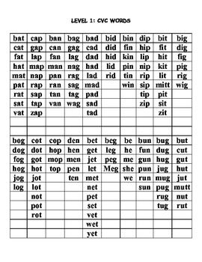

<https://www.enchantedlearning.com/wordlist/> This site has themed word lists

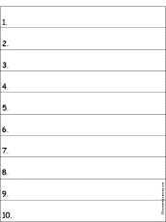 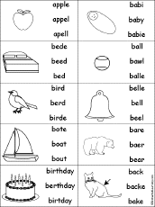 (if audio doesn’t work)

Themed word lists examples – furniture, beach (x 2), colours, harder colours, animals (hard level), + easy to make an easy level, other theme ideas – school, family, work, kitchen, tools, toys,

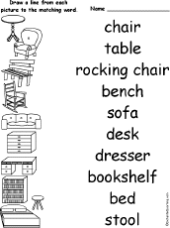 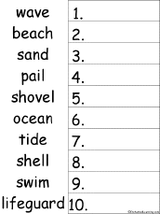 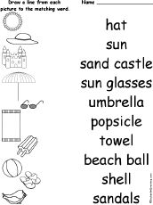

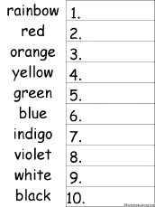 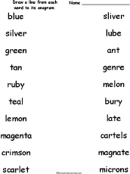 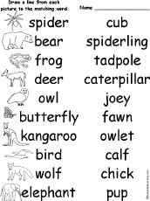

**Themed Word Lists – Level 1**

|  |  |  |  |  |  |  |  |
| --- | --- | --- | --- | --- | --- | --- | --- |
| ANIMALS | SCHOOL | COLOURS | BIRTHDAY | FOOD | BEACH | PARK | HOME |
| dog | school | red | cake | jam | beach | play | door |
| frog | year | green | food | apple | sun | walk | bed |
| bird | week | blue | party | egg | sea | run | floor |
| pig  snake | table  chair | yellow  black | fun  toy | toast  lunch | water  sand | grass  park | pet  food |
| goat | book | brown | play | cook | ball | path | toy |
| cow | paper | gold | games | eat | crab | skip | book |
| cat | neat | white | card | bread | hat | fun | bath |
| horse | class | pink | clown | jelly | ocean | sport | tap |
| lion | study | cream | child | nut | swim | tree | rug |

**Themed Word Lists – Level 2**

|  |  |  |  |  |  |  |  |
| --- | --- | --- | --- | --- | --- | --- | --- |
| ANIMALS | SCHOOL | COLOURS | BIRTHDAY | FOOD | BEACH | PARK | HOME |
| owl | office | orange | friends | cheese | sandals | throw | window |
| deer | homework | crimson | family | banana | surfboard | catch | hallway |
| jaguar | recess | purple | parcel | sandwich | vacation | chase | computer |
| zebra | writing | olive | donkey | lettuce | relaxing | swing | shower |
| crocodile | library | indigo | balloon | dough | sunscreen | outdoor | doorbell |
| flamingo | assembly | grey | birthday | breakfast | rescue | garden | lounge |
| platypus | canteen | teal | candle | butter | goggles | reserve | backyard |
| kangaroo | playground | silver | cupcake | custard | bikini | fence | laundry |
| walrus  elephant | award  science | emerald  beige | festive  present | dinner  salad | dune  towel | soccer  cricket | chores  lawn |

**Themed Word Lists – Level 3**

|  |  |  |  |  |  |  |  |
| --- | --- | --- | --- | --- | --- | --- | --- |
| ANIMALS | SCHOOL | COLOURS | BIRTHDAY | FOOD | BEACH | PARK | HOME |
| narwhal | dictionary | mauve | gathering | casserole | snorkel | frisbee | wardrobe |
| porpoise | mathematics | chartreuse | invitation | ingredients | lifeguard | gymnastics | telephone |
| quokka | principal | cerulean | lollipop | recipe | underwater | adventure | loungeroom |
| caterpillar  giraffe | information  introduction | burgundy  khaki | chocolate  celebration | muesli  baclava | chlorine  scuba | activity  playground | awning  pergola |
| tortoise | conclusion | lavender | confetti | mayonnaise | current | wildlife | renovation |
| penguin | knowledge | maroon | guest | pumpkin | beachball | eucalyptus | balcony |
| newt | narrative | sapphire | pinata | mousse | sandbar | community | banister |
| vertebrates | stationery | turquoise | receive | dessert | sunglasses | facility | furniture |
| tapir | literature | puce | wrapping | rotisserie | sandcastle | mosquio | address |